# CS 255 System Design Document Template

## UML Diagrams

### UML Use Case Diagram

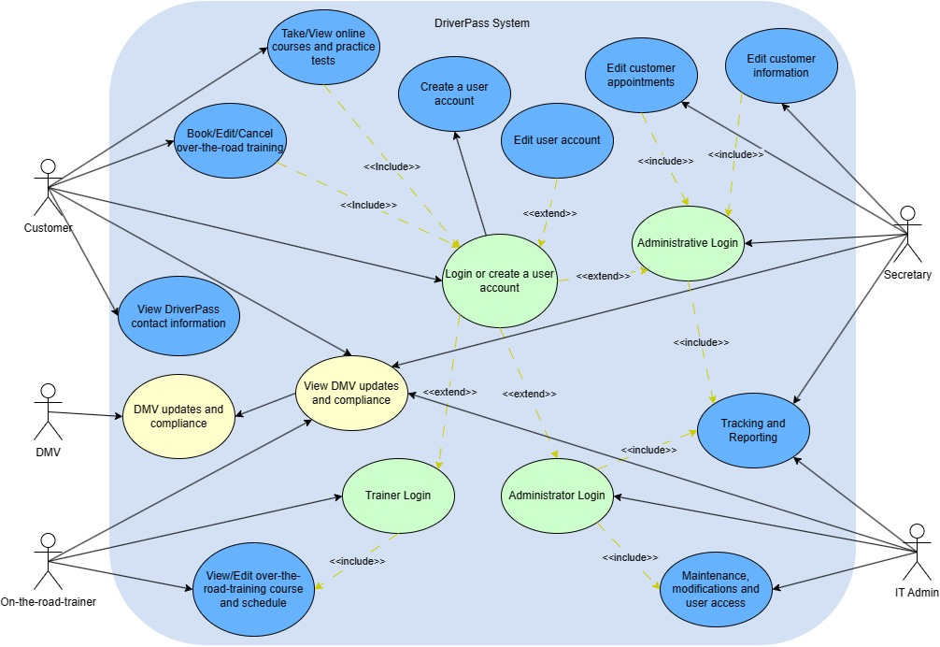

### UML Activity Diagrams

### 

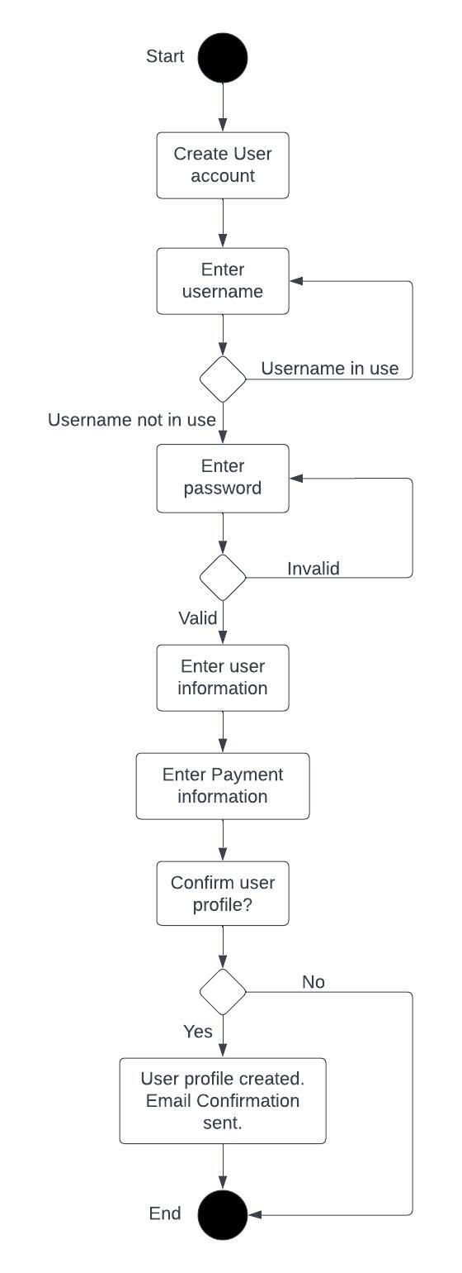

### UML Sequence Diagram

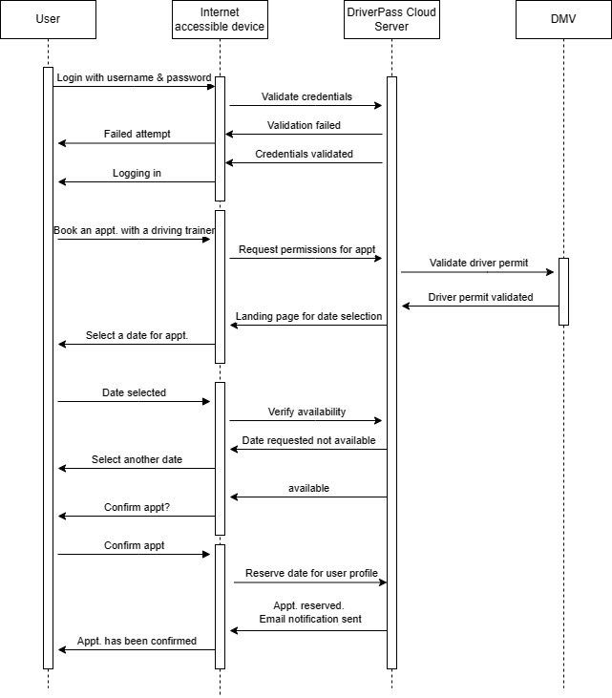

### UML Class Diagram

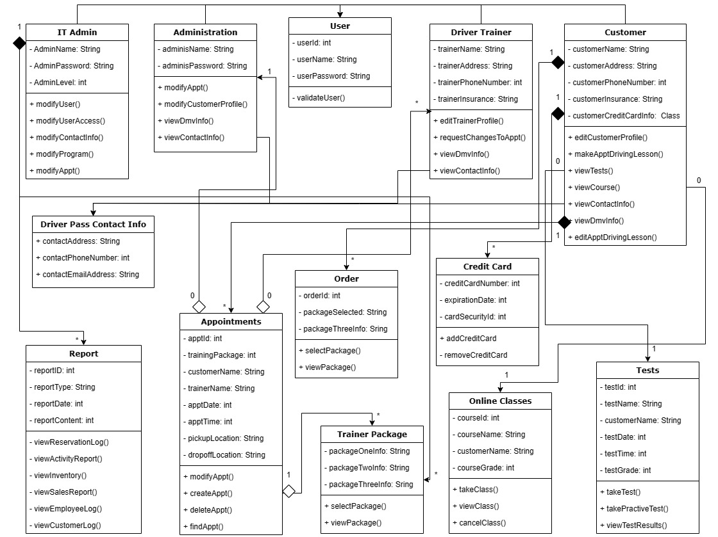

## Technical Requirements

Hardware required:

* Monitor, keyboard, and mouse
* Server (Cloud recommended for scalability)
* Power sources
* Internet provider
* Network cables and routers for server and equipment
* Desktop/laptops for employees to access web browser

Software required:

* DriverPass software
* Operating system (Windows, Linux, Andriod, Mac)
* Software for virtual machine traffic
* Security software

Tools required:

* Computers with Driverpass software uploaded
* Good internet connection for server upload
* Admin tools and programs to monitor network

Infrastructure:

* Fleet of vehicles for driver training
* Physical location for the DriverPass office.
* High speed internet access
* Cloud based server